Joseph Edward Hodges
CCHS Class of 1947
Inducted in Inaugural Hall of Fame class of 1997
- Graduate of University of Tennessee
- Masters degree from Duke University
- Organized first Art and Drama departments at CCHS (as an educator)
- Received Governor’s award for Art in 1992
- Art educator for 35 years
- Member of first Tennessee Arts Commission
- Worked on historic preservation for the Palace Theater and Pioneer Hall in Pleasant Hill
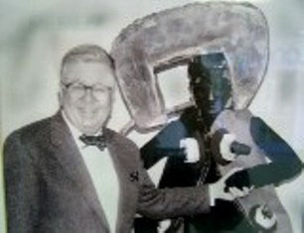
Lieutenant General William Odom
CCHS Class of 1949
Inducted in Inaugural Hall of Fame class of 1997
- Member of CCHS football team 1945-1948
- All Conference guard 1948
- Appointed to West Point Military Academy
- Graduated from West Point as 2nd Lieutenant 1954
- Received PhD from Columbia University in 1970
- Promoted to Lieutenant General in 1984
- Served as Director of National Security for US Department of Defense
- Author of five books and 131 articles
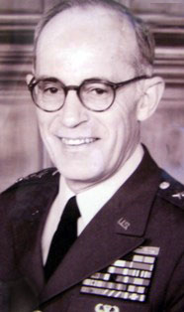
Curt Watson
CCHS Class of 1968
Inducted in Inaugural Hall of Fame class of 1997
- Member of CCHS football team
- Outstanding football career at University of Tennessee 1969-1971
- Known as “Crossville Comet” during his football career
- Three-time All southeastern Conference Running Back
- University of Tennessee retired his number 31 football jersey
- Graduate of University of Tennessee
- Member of US Navy famed Blue Angels
- Responsible for securing Blue Angels jet mascot that stands on present CCHS campus
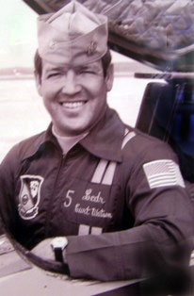

Margaret Keyes Harrison
CCHS Class of 1921
Inducted in Inaugural Hall of fame class of 1997
- Attended University of Tennessee
- Active in PTA, Art Circle, McDowell Music Club, Garden Club and DAR
- Original incorporator of Cumberland County Playhouse
- Senior Partner in Trade-A-Plane Publishing
- Assisted in establishing many post-secondary scholarships
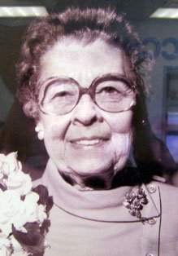
O.C. Stewart
Pleasant Hill Academy Class of 1944
Inducted in Inaugural Hall of Fame class of 1997
- Graduated from North Carolina State in 1952
- Masters from Vanderbilt University in 1955
- Earned Doctor of Education degree from University of Tennessee in 1965
- Career in education spanned 50 years
- Served as Superintendent of Schools in Cumberland County from 1960-1964
- Associate Director of University of Tennessee School of Planning
- Dean of Extended Services at Tennessee Technological University
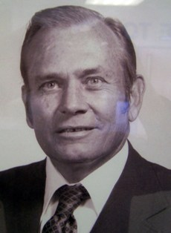

Diane Dorton Brown
CCHS Class of 1949
Inducted 1998
- Attended Vanderbilt University
- B.S and Masters from Peabody College
- Taught at CCHS for 25 years
- Selected Teacher of the Year three times
- President of Cumberland County Education Association
- Senior Vice President, Union Planters bank
- Instrumental in establishing local campus for Roan State Community College
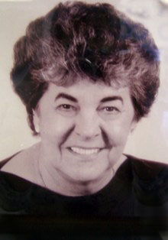
L.A. Fox Sr.
CCHS Class of 1947
Inducted 1998
- Served in US Army in WWII
- Graduated from Tennessee Tech
- Served as Basketball coach at Pleasant Hill High School from 1951-1955
- Coached football and girls’ basketball at CCHS, winning five district titles in six years
- Organized Little League baseball and adult softball leagues
- 1960 Tri-County coach of the Year
- Annual tennis tournament named The L.A. Fox Tournament Classic
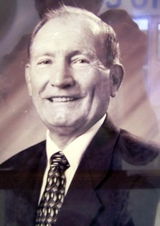

Major General George Edwards
CCHS Class of 1947
Inducted 1998
- Attended University of Tennessee
- Graduate of University of Maryland
- Received Air Force Commission and Wings in 1952
- Flew more than 100 combat missions in Korea
- Set world flying speed record in 1959
- Flew 313 missions during the Vietnam War
- Distinguished graduate of the Army War College
- Commanded U.S and Korean Air Forces
- Military awards include Defense Distinguished Service Medal, Air Force Distinguished Service Medal, two Legions of Merit, four Distinguished Flying Crosses, 20 Air Medals, and the Bronze Star
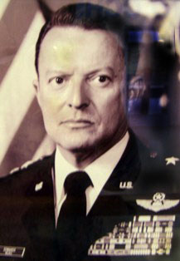
John Dooley
CCHS Class of 1945
Inducted 1999
- Worked in family business for 40 years
- Winner of Jefferson Award in 1986
- Served as volunteer firefighter for 35 years
- Organized Auxiliary Police Department
- Member of American Legion for 40 years
- Served three terms as Crossville Mayor
- City Councilman for 21 years
- County commissioner for 12 years
- State Representative 1965-1966
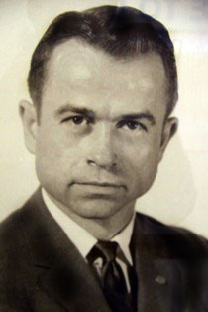
Benton Bilbrey
CCHS Class of 1939
Inducted 2000
- 3-sport athlete at CCHS—Football, Basketball, Boxing
- All Conference 2 years—football and Basketball
- Football scholarship to TTU 1939-1943
- Tennessee Tech Sports Hall of Fame 1970
- Football and Basketball coach at CCHS 1946-1955
- Centerfielder for Crossville Blues, late 1940s-early 1950s
- Started and supervised youth recreation program for City of Crossville
- Served county school system for 35 years
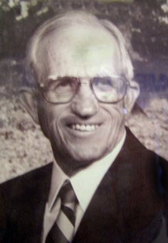
Dr. Ernest Wells
CCHS Class of 1940
Inducted 2002
- Member of Air Force during WWII
- Graduated from Tennessee Tech School of engineering 1957
- PhD from college of Technology, Sussex, United Kingdom 1974
- Lead two expeditions to Greenland Ice Cap
- NASA Project engineer on geophysical satellites
- Helped in discovery of water on Mars
- Recipient of Apollo-Soyuz Award and Award of Achievement from NASA
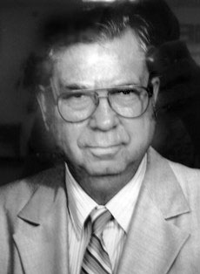
Paul Ervin, MD
CCHS Class of 1937
Inducted 2001
- Graduated from high school at 16
- Graduate University of Tennessee Knoxville 1941
- Graduate UT Medical School
- Inducted into US Army Medical Corp 1945
- Co-founder Crossville Medical Group
- Practiced medicine for over 40 years
- Served as Health Department physician for 13 years
- Outstanding medical career for over 50 years
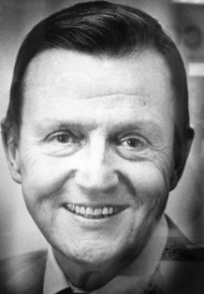

Reba Russell Reed
CCHS Class of 1955
Inducted 2002
- Graduate TTU 1961
- Active in Calvary Baptist Church
- Served county school system for 40 years
- Three-time nominee for Cumberland County Teacher of the Year
- Listed in Who’s Who Among America’s Teachers 1994
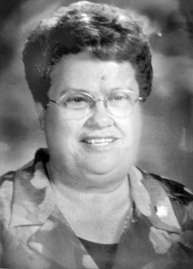

Kenneth Moles
CCHS Class of 1953
Inducted 2003
- Member of Red Devil football team
- 20 years in US Air Force
- Retired as Master Sergeant
- Awarded Air Force Commendation Medal, Bronze Star, National Defense Service Medal
- Founding member of Crossville Boys’ and Girls’ Club
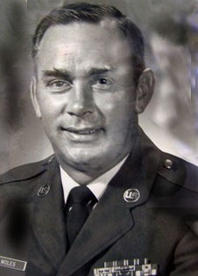
Joanne Harrison Stone
CCHS Class of 1940
Inducted 2003
- CCHS class Valedictorian
- BS from the University of Tennessee in Physics
- Original partner of Trade-a-Plane
- President of Art Circle, and of Mental Health Association
- Served on Board of Cumberland County Playhouse
- Active in Crossville United Methodist Church
- Supported education in Cumberland County by donating land for Stone Elementary, Stone Memorial High School and Roane State Community College Crossville Campus
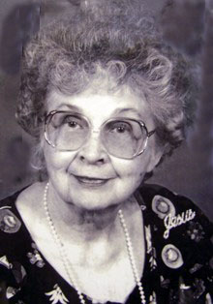

Kate Peterson
CCHS Class of 1927
Inducted 2004
- CCHS class Salutatorian
- Graduate of the University of Tennessee and Peabody College
- Teaching career spanned 44 years
- Active member of United Methodist Church
- Extensive traveler and has visited every state in the U.S. and many foreign countries
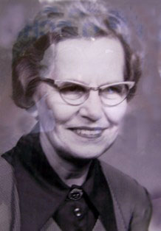
William Eston (Bill) Mayberry, Jr.
CCHS Class of 1940
Inducted 2004
- Member of CCHS Football and Basketball Teams
- Served in US Army in Europe during WWII
- Graduate of University of Tennessee in 1947
- Mayor of Crossville in 1950 at age 28
- Founding member of local United Fund
- Served Crossville United Methodist Church for 65 years
- Worked in/owned/operated family business for over 50 years
- Served on City Council and numerous civic boards
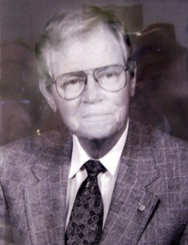

Glenn Miller
CCHS Class of 1933
Inducted 2005
- Served in US Navy
- Executive Director of United Fund of Cumberland County
- Served United Fund for 30 years
- Active in many service oriented organizations
- County Commissioner 1952-1956
- Cumberland Medical Center Board of Directors
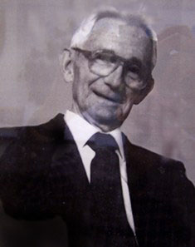

Kimberley Loomis
CCHS Class of 1981
Inducted 2005
- BS in microbiology from East Tennessee State University
- M.S. and PhD from University of Tennessee in Science Education
- Career includes teaching at elementary, secondary and college levels
- Participated in wolf education research
- Recipient of 14 prestigious awards
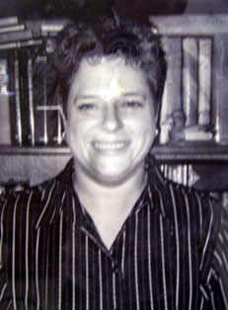
Lyle Smith, MD
CCHS Class of 1939
Inducted 2006
- Attended Beloit College in Wisconsin
- Served in Army Air Force in WWII
- Received Flying Cross Award
- Taught at CCHS 1946-1947
- MD from Cornell University 1951
- Practiced medicine in Kingsport, Tennessee from 1953-1991
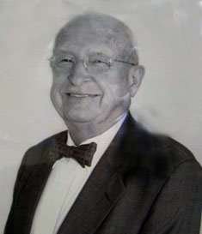
Dan Wheeler
CCHS Class of 1960
Inducted 2006
- BS in Agriculture from the University of Tennessee in 1964
- Held many positions in Tennessee Farm Bureau, including agent, regional field representative, assistant director, chief legislative lobbyist, and chief administrative officer
- 32nd Commissioner of Agriculture in Tennessee
- Served on University of Tennessee Board of Trustees and Tennessee Board of Regents
- Served as president of Southern United States Trade Association
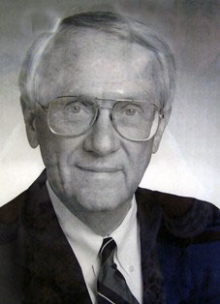

Ruby Wyatt Davis
CCHS Class of 1943
Inducted 2007
- Beloved Cumberland County educator for 31 years
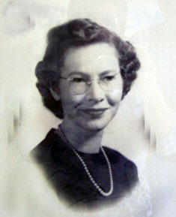

Jim Purcell
CCHS Class of 1955
Inducted 2008
- 1959 Graduate of Tennessee Tech
- Taught at Pleasant Hill School from 1959 -1962
- Served in the Tennessee Army National Guard for 8 years
- Held many postitions from teacher, counselor, financial aid administrator,and director over his 38 year career at the Technology Center
- Served as director for 21 years at the TTC of Crossville
- Scoutmaster of Troop #374 of the Boy Scouts of America
- Active member of the CCHS Red Devils Alumni Association
- President of Cumberland Good Samaritans Board of Directors
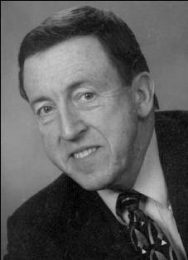
Carol Brown Darling
CCHS Class of 1982
Inducted 2009
- Member, Downtown Crossville, Inc. revitalization project
- Palace Theater restoration committee member
- Member and Chairman of the Art Circle Public Library Board of Trustees
- Member Caney Fork Regional Library Board
- Named 2008 Trustee of the Year by the Tennessee Library Association
- Advocacy on behalf the of the Art Circle Public Library resulted in Cumberland County’s acquiring a new $6M library facility
- Dedicated parent volunteer to Cumberland County school system
- Re-accreditation Committee at CCHS
- Committee for the development and implementation of the Renaissance Program at CCHS
- Cumberland County Sesquicentennial Committee
- Recipient, Dimpled Globe Community Communicator Award, 2007
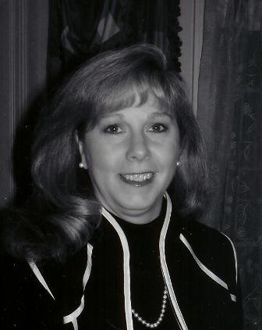

Randy Graham
CCHS Class of 1974
Inducted 2010
- B.S in Business, Tennessee Technological University
- Attended Vanderbilt School of Banking
- Attended LSU banking school
- Held various positions with Cumberland County Bank, People’s Bank and Trust of the Cumberlands, and First National Bank of the Cumberlands
- CEO – First National Bank of Tennessee
- Crossville/Cumberland County Chamber of Commerce—served two consecutive terms as Chairman
- Charter member and Treasurer of Art Circle Public Library Foundation
- Active in supporting area churches, schools, civic and charitable organizations
- Advocate for support of military personnel and their families
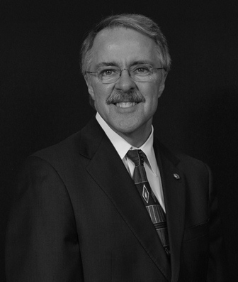

Lieutenant Colonel John Trenton Dooley
CCHS Class of 1973
Inducted 2011
- Bachelor of Science, International Relations, Middle Tennessee State University
- Masters of Business Administration, Georgetown University
- Graduate of U.S. Army Command and General Staff College
- Retired as Lieutenant Colonel after 28 years in U.S. Army
- Member of Airborne Rangers
- Associate Professor at U.S. Military Academy at West Point
- Served as Military Advisor to the Secretary General of the United Nations
- Coordinated United Nations Crisis Action Response Team
- Professor and Chair of Military Science at Fordham university
- Vice President of Extended Learning at National University
- CEO of USO San Diego, serving more than 150,000 soldiers annually
- Active in many community organizations that support military families


Glenda Miller Bond
CCHS Class of 1965
Inducted 2012
- Bachelor of Science Degree--University of Tennessee
- Masters in Curriculum and Instruct and Special Education/Early Intervention—Tennessee Technological University
- Vocational Home Economics Teacher CCHS
- Director, Mothers’ Day Out
- Nutrition Educator, Cumberland County Health Department
- Special Education Resource teacher, CCHS
- Special Education Services Coordinator, Cumberland County School System
- Mother of the Year 1984
- ARC of Tennessee Volunteer of the Year 1987
- Business & Professional Women Woman of Achievement 1997
- Dimpled Globe Award 2009
- Fair Park Senior Center History Woman of the Year 2012
- President, ARC of Tennessee 1993-1995 and 2009-2011
- President ARC of Cumberland county
- Board Member ARC of Cumberland County and ARC of Tennessee 1984-Present
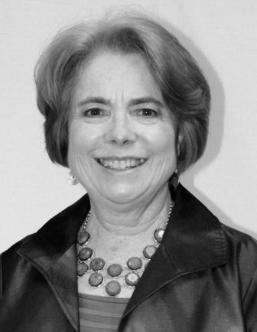
Tonya Hinch
CCHS Class of 1981
Inducted 2013
- Captain Lady Jets Basketball Team
- Miss CCHS 1981
- Editor CCHS yearbook, The Plateau, and school newspaper, The Contrail
- Graduate-University of Tennessee 1985
- General Manager Neutrogena Corporation
- Executive Vice President Edison Schools
- Henry Crown Fellow of the Aspen Institute
- Owner of Don Hinch & Associates Insurance Company
- Active in numerous service-oriented organizations


